California Inland Empire Council, BSA
PO Box 8910/1230 Indiana Court
Redlands, CA 92375-2110
909-793-2463/fax 909-793-0306
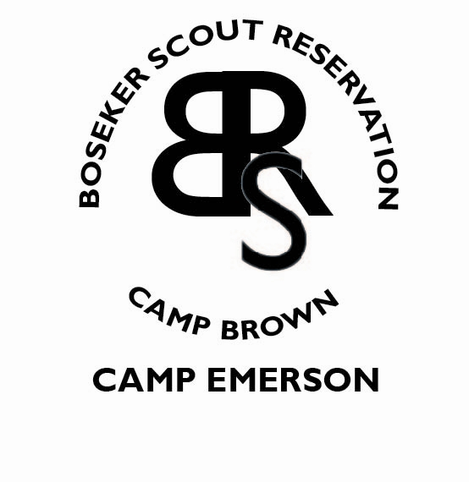

Today’s Date: ________________
Check camp applying to:
- Camp Emerson Boy Scout Camp
- Wiley Cub Scout Camp
2017 Application for Seasonal Summer Camp Staff

Please Print Clearly in Ink
First Name: _____________________________________ Last Name: _____________________________
Home Phone: ___________________________________ Cell Phone: ____________________________
Mailing Address: ___________________________________________________________________________________________
Street City State Zip
E-Mail Address: _________________________________________________
Will be available for employment (give exact dates): From: ______________________ To: ________________________

Position Being Applied For
Please indicate your top three preferences. If hired, camp management reserves the right to re-assign staff.
(Minimum age listed – by checking a position you are acknowledging that you are at least that age)

❑ Camp Director | (25) |  | ❑ Nature Director | (18)
❑ Program Director | (21) |  | ❑ Nature Instructor | (15)
❑ Aquatics Director | (21) |  | ❑ Office Assistant | (18)
❑ Aquatics Instructor | (15) |  | ❑ Outdoor Skills Director | (18)
❑ Archery Director | (18) |  | ❑ Outdoor Skills Instructor | (15)
❑ Archery Instructor | (16) |  | ❑ Shooting Sports Instructor | (21)
❑ Assistant Ranger | (18) |  | ❑ Shooting Sports Director | (21)
❑ BB Instructor -Wiley | (16) |  | ❑ Sports Director - Wiley | (18)
❑ Commissioner | (21) |  | ❑ Sports Instructor - Wiley | (15)
❑ Trading Post Director | (21) |  | ❑ STEM Director | (18)
❑ E-Team Director | (21) |  | ❑ STEM Instructor | (16)
❑ E-Team Instructor | (18) |  | ❑ Theme Director - Wiley | (18)
❑ E-Tm Mountain Bike Leader | (18) |  | ❑ Theme Instructor - Wiley | (15)
❑ Handicraft Director | (18) |  | ❑ Trading Post Clerk | (18)
❑ Handicraft Instructor | (15) |  | ❑ Health Officer – EMT | (18)

Certification
Do you have: |  | Yes | No | Expiration Date
1. | A BSA National Camping School Certificate?  Which Course? _________________________________________________________ | ❑ | ❑ | ___________________
2. | An American Red Cross Water Safety Instructor’s Certificate? | ❑ | ❑ | ___________________
3. | Other Aquatic or Lifesaving Training:  ________________________________________________________ | ❑ | ❑ | ___________________
4. | NRA Rifle/Pistol/Shotgun/MLR Instructor and/or RSO Certificate? CIEC BB Range Master? (Circle appropriate instructor certificates) | ❑ | ❑ | ___________________
5. | USAA/NFAA Level 1 / 2? | ❑ | ❑ | ___________________
6. | Standard First Aid Certification? | ❑ | ❑ | ___________________
7. | Advanced First Aid/EMT Certification? | ❑ | ❑ | ___________________
8. | CPR/AED Certification? | ❑ | ❑ | ___________________
Camp Experience

1. As a Scout: 3. As a Scout Staff Member:
Camp Location Dates Camp Location Dates
___________________________________________________ __________________________________________________
___________________________________________________ __________________________________________________
___________________________________________________ __________________________________________________

2. Adult Scouting: 4. Non-Scout Camps Attended:
Camp Location Dates Camp Location Dates
___________________________________________________ __________________________________________________
___________________________________________________ __________________________________________________
___________________________________________________ __________________________________________________

Scouting Experience

1. Are you currently registered in Scouting?  Yes  No 3. Youth Scouting Experience:
If registered, list position(s) held: ___________________ __________Years in Cub Scouts
__________________________________________________ __________Years in Boy Scouts
Unit number: ______________________________________ __________Years in Venturing or Exploring
Council registered in: ______________________________ Highest Scout Rank: ____________________________

2. Past Adult Scouting Registration: 4. Are you a member of the Order of the Arrow?
Position Council Year Yes  No
__________________________________________________  Ordeal  Brotherhood  Vigil
__________________________________________________ 5. BSA Training
__________________________________________________  Cub Scout Leader Basic Training
❑ Boy Scout Leader Basic Training
❑ Wood Badge Training
❑ BSA Youth Protection Training

Education
Highest grade completed: _________________________ School: __________________________________________
Major: ___________________________________________ Other: ___________________________________________

Other Related Experience/Qualifications

Sports: __________________________________________ Musical: _________________________________________
Hobbies: ________________________________________ Talents: __________________________________________
Clubs/Associations: ________________________________________________________________________________________
Awards: ___________________________________________________________________________________________________
Other: _____________________________________________________________________________________________________

__________________________________________________________________________________________
Employment Experience and Reference – other than Boseker Scout Reservation
(List most recent)
Employer/Position | Address | Phone # | From | To
 |  | ( )
 |  | ( )
 |  | ( )

Personal References
(List at least three)
Reference | Address | Phone # | How long known?

Are you permitted to become lawfully employed in the United States?  Yes  No
(Proof of citizenship or immigration status is required upon employment – Form I-9)

Additional Information
 |  | YES | NO
1. | Do you use illegal drugs? | ❑ | ❑
2. | Have you ever been convicted of a criminal offense? (If yes, please explain below.) | ❑ | ❑
3. | Have you ever been charged with child neglect or abuse? | ❑ | ❑
4. | Other than the above, is there any fact or circumstance involving you or your background that would call into question your being entrusted with the supervision, guidance, and care of young people? (If yes, explain below.) | ❑ | ❑

Carefully read the following statements before signing
I, the undersigned, understand that:
- If employed on the Council Camp Staff, I will be required to become registered as a member of the Boy Scouts of America, and to have a current (within one year) medical examination. A criminal background check is conducted on all adult registrants.
- The information that I have provided may be verified by contacting persons or organizations named in this application, and I hereby release and agree to hold harmless from liability any person or organization that provides information concerning me to the Boy Scouts of America or the California Inland Empire Council, Inc.
- Rules for acceptance and participation in the camp program and staff are the same for everyone without regard to race, color, national origin, age, sex or handicap. The California Inland Empire Council is an Equal Opportunity Employer.
- In signing this application, I affirm that the information that I have given herein is true and correct.
Applicant’s Signature: ____________________________________________________________ Date: _______________________
Signature of parent or guardian (if under age 18) ____________________________________ Date: ___________________________

