**Kick off 2017 by making an Endowment Gift in honor of an Eagle Scout, Silver Beaver recipient, retirement, special accomplishment, anniversary—or in memory of a special individual.**

What are Endowments? Endowments are permanent restricted funds established by a Donor whereby only the interest each year is used for the specified purpose of the fund. ... While a donor may contribute cash, stock or other gift for immediate use, a gift designated to an endowment is an investment in the future.

A gift to the California Inland Empire Council, designated by the donor to the council endowment fund, qualifies for membership as a James E. West fellow.  The gift must be in addition to— and not replace or diminish—the donor’s annual Friends of Scouting support.  A minimum gift of $1000 in cash or marketable securities qualifies for the Bronze level membership. Donors may make cumulative gifts to reach Silver, Gold, and Diamond member levels.  For example, 5 years of giving at the Bronze level would qualify for Silver level membership.

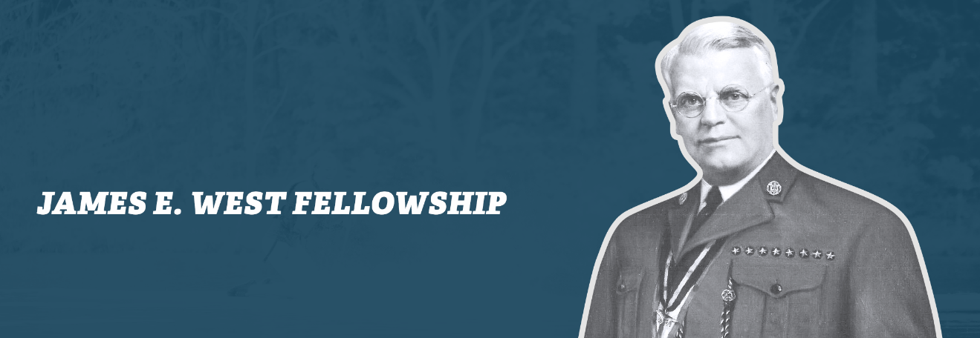

GROWING FUTURE LEADERS

**James E. West (1876-1948)**

Orphaned at age six and afflicted with tuberculosis, James E. West never had much of a childhood. West had to fight for permission to attend school outside of his orphanage—and only if he did his extensive orphanage chores before and after school. Nonetheless, he finished high school in two years, graduating with honors in 1895. By 1901, he’d worked his way through law school and was practicing law in Washington, D.C.

Given those circumstances, it was not surprising West gravitated toward children’s issues. When a young boy stole his car, he declined to press charges, offering instead to represent the boy in court (he got him off on a technicality). This incident led West to lobby successfully for the creation of a juvenile court. He also worked for the Washington Playground Association and the YMCA and prompted President Theodore Roosevelt to convene a White House Conference on Dependent Children in 1909.  Given his background, West became a natural choice to serve as the first Chief Scout Executive. He agreed to take the job for up to six months and stayed on for 32 years.

**http://www.bsafoundation.org/donor-information/donor-recognition/westfellowship/**