**Webelos-to-Scout Transition Plan**

Discover ways to make the move

for new Boy Scouts natural and fun

**Join today.**

**BeAScout.org**

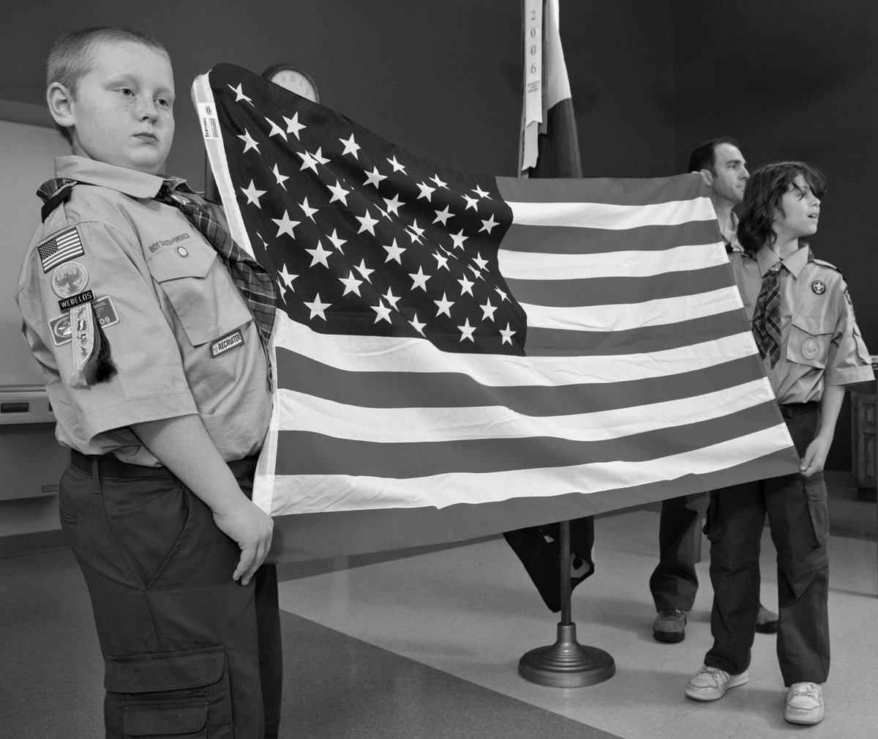

Webelos-to-Scout

**Webelos-to-Scout Transition Timetable**

**August**

* Get names, addresses, and telephone numbers of second-year Webelos.
* Plan a joint Boy Scout troop/Webelos den camping trip for October.
* Plan a program of upcoming events to present at a Webelos den meeting visit in November.
* Select a den chief for each Webelos den.

**September**

* Mail a letter of introduction from the Boy Scout troop to second-year Webelos Scouts to introduce them to the troop.
* Put second-year Webelos Scouts on the mailing list to receive the troop newsletter.
* Continue planning the joint camping trip for October.

**October**

* Conduct the joint camping trip with the Webelos den.

**November**

* Attend a Webelos den meeting to teach the Webelos Scouts how the Boy Scout troop works.
* Have den chiefs attend a local council or district training course.

**December**

* Set a date for Webelos Scouts and their par­ents to visit a Boy Scout troop meeting in January.
* Send a form of information or greeting, letting Webelos you look forward to them joining the troop.

**January**

* Host Webelos Scouts and their parents at a Boy Scout troop meeting.
* Plan a bridging ceremony for the blue and gold banquets in February to welcome gradu­ating Webelos Scouts to their new troop.
* Attend a meeting for first-year Webelos Scouts to introduce them to Boy Scouting.

**February**

* Hold the bridging ceremony at the blue and gold banquet.
* Get new Scouts actively involved with the troop through troop activities.
* Recruit parents of new Scouts to become assistant Scoutmasters or troop committee members.

**March**

* Plan a troop activity for new Scouts to get them involved with their new troop.

**April**

* Conduct summer camp orientation to encourage troop involvement.
* Attend a meeting of Bear Cub Scouts to introduce them to Boy Scouting.
* Sponsor a troop activity for new Scouts.

**May**

* Work closely with new Scouts and parents during their transition to the Boy Scout troop, ensuring their needs are met and that their move has been natural and fun.
* Work on rank advancement with new Scouts.

**June**

* Ensure that all new Scouts attend summer camp.

**July**

* Work closely with new Scouts and parents during their transition to the Boy Scout troop, ensuring their needs are met and that their move has been natural and fun.
* Work on rank advancement with new Scouts.

Webelos-to-Scout

**District Webelos Transition Chair**

* Contact all packs in early fall to update a list of all fifth-grade Webelos Scouts.
* Coach Cubmasters and Webelos den leaders in the transition process at roundtables, training courses, and through personal contact.
* Report to the membership committee chair, and keep the district committee informed.
* Track and maintain records of Webelos graduation by using a wall chart that lists the transition record of each pack.
* Work with unit commissioners to follow up on Webelos Scouts who have not joined a troop.
* Work toward 100 percent Webelos transition.

Webelos-to-Scout

**Troop Responsibilities**

* Select Scouts to serve as den chiefs for each Webelos Scout den and Cub Scout den. Arrange for   
  Den Chief Training.
* Serve as a resource for overnight activities. The troop can be of service to provide equipment, leadership, and logistics for Webelos parent-son campouts.
* Conduct an orientation in the Bear Cub Scout dens to explain the changing role as boys become Webelos Scouts, and then again as they become Boy Scouts. Explain how being a Webelos Scout will help prepare them for Boy Scouting.
* Webelos den/Scout troop campouts should show Webelos Scouts and their parents what to expect when they move into the troop. The troop should cook and camp by patrol, and use skills in which the Webelos Scouts can participate.
* Arrange for Webelos dens to visit a troop meeting. This should be planned several weeks in advance.
* Provide each Webelos Scout a copy of the troop’s activities for the upcoming year.
* Work with Webelos den leaders to encourage them to plan to move into the troop with their Webelos Scouts and to serve either as committee members or assistant Scoutmasters.
* Conduct a Scoutmaster conference under the guidance of the Scoutmaster or the assistant designated by the Scoutmaster. This conference should cover the meaning of the Scout Oath and Scout Law, the advancement program, troop camping, the patrol method, summer camp, and personal equipment.
* Work with the Cubmaster in planning a meaningful transition ceremony at the pack’s blue and gold banquet. Coordinate the ceremony and arrange for each Webelos Scout to receive a troop neckerchief and *Boy Scout Handbook* along with his Arrow of Light Award. Members of the Order of the Arrow may assist in the ceremony.

Webelos-to-Scout

**Unit Commissioner Responsibilities**

* Be a catalyst in developing good relationships between troop and pack leaders.
* Promote communication by scheduling a meeting of key volunteers.
* Help plan a Webelos den visit to a troop meeting and other joint activities.
* Keep the pack and troop on schedule as plans develop for the transition ceremony at the blue and gold banquet.
* Attend the transition ceremony.
* Be sure new Scouts have completed a Boy Scout application, that they have a copy of the troop’s activities, and that they know when and where the troop meets.
* Work with the pack and troop in their charter renewal process to help ensure Webelos Scouts are moved from pack rosters to troop rosters.
* Work with the Webelos transition chair to follow up on boys who have not yet joined a troop. Make sure they are invited to join a troop.
* Be sure Webelos Scouts join a troop in time to prepare for Boy Scout summer camp.

Webelos-to-Scout

**Pack Responsibilities**

* Develop a working relationship with the leadership of a Boy Scout troop or troops in the community. Most troops should have either an assistant Scoutmaster or a committee member assigned to new Scouts. Your unit commissioner can help put you in contact with troop leaders.
* Compare calendars of troop and pack activities to coordinate the activities. Community events can be done together, and planning can help prevent conflicts in the use of equipment and facilities.
* Work with troop leaders to secure den chiefs for each Webelos den and Cub Scout den.
* Work with troop leaders to plan and conduct Webelos overnight activities.
* Work with troop leaders to plan visits to troop meetings. Never show up without first calling in advance.
* Invite the Scoutmaster and troop youth leaders to special pack activities. This will help create familiarity and a level of comfort for the Webelos Scouts and their parents as they ease into the troop.
* Plan a meaningful transition ceremony at the pack’s blue and gold banquet. Have troop lead­ership be present to accept the Webelos Scouts as they graduate to Boy Scouting. The local Order of the Arrow lodge can often be a valuable resource in conducting ceremonies.
* Webelos leaders should be strongly encouraged to move into the troop with the boys, either as assistant Scoutmasters or troop committee members. This will give the new Scouts a familiar face at troop meetings and a connecting link to Boy Scouting.
* If a troop does not exist in your community, discuss with the head of the pack’s chartered organization the possibility of organizing a troop. A graduating Webelos den can form the nucleus of   
  a new troop.

Webelos-to-Scout

**Webelos Scout Tracking Form**

**Pack No.: __________________________________ Email: _____________________________________**

**Webelos Leader: ____________________________ Phone number: _____________________________**

|  |  |  |  |  |  |  |  |  |  |
| --- | --- | --- | --- | --- | --- | --- | --- | --- | --- |
| Name | Still Active (Yes/No) | Not Active (Indicate Why) | | | | | Transitioning (Yes/No) | Troop Visited | Earned Arrow of Light |
| No Scouting Interest | Other Interest | Leadership Relationship | Lack of Program | Other |
|  |  |  |  |  |  |  |  |  |  |
|  |  |  |  |  |  |  |  |  |  |
|  |  |  |  |  |  |  |  |  |  |
|  |  |  |  |  |  |  |  |  |  |
|  |  |  |  |  |  |  |  |  |  |
|  |  |  |  |  |  |  |  |  |  |
|  |  |  |  |  |  |  |  |  |  |
|  |  |  |  |  |  |  |  |  |  |
|  |  |  |  |  |  |  |  |  |  |
|  |  |  |  |  |  |  |  |  |  |
|  |  |  |  |  |  |  |  |  |  |
|  |  |  |  |  |  |  |  |  |  |
|  |  |  |  |  |  |  |  |  |  |
|  |  |  |  |  |  |  |  |  |  |
|  |  |  |  |  |  |  |  |  |  |
|  |  |  |  |  |  |  |  |  |  |
|  |  |  |  |  |  |  |  |  |  |
|  |  |  |  |  |  |  |  |  |  |
|  |  |  |  |  |  |  |  |  |  |
|  |  |  |  |  |  |  |  |  |  |
|  |  |  |  |  |  |  |  |  |  |
|  |  |  |  |  |  |  |  |  |  |
|  |  |  |  |  |  |  |  |  |  |
|  |  |  |  |  |  |  |  |  |  |
|  |  |  |  |  |  |  |  |  |  |
|  |  |  |  |  |  |  |  |  |  |
|  |  |  |  |  |  |  |  |  |  |
|  |  |  |  |  |  |  |  |  |  |
|  |  |  |  |  |  |  |  |  |  |
|  |  |  |  |  |  |  |  |  |  |
|  |  |  |  |  |  |  |  |  |  |
|  |  |  |  |  |  |  |  |  |  |
|  |  |  |  |  |  |  |  |  |  |
|  |  |  |  |  |  |  |  |  |  |
|  |  |  |  |  |  |  |  |  |  |
|  |  |  |  |  |  |  |  |  |  |
|  |  |  |  |  |  |  |  |  |  |

Webelos-to-Scout

**Samples of Transition Ceremonies**

Webelos Scouts to Boy Scouts

***Colors of the Wind***

**Materials:** Holder with four candles or lights (blue, yellow, white, and red). Webelos den leader lights the candles. Have a trail ready if you are using one in this ceremony.

NARRATOR: Tonight, we are honoring some Webelos Scouts who are moving forward along the Scouting trail. Will the following boys please come forward?   
(*Call the names*)

Today, you are making a giant step—that from Cub Scouting to Boy Scouting. As we present to you the colors of the four winds, remember them, and let them continue to guide you along the Scouting trail.

(*Light the blue candle or light*.) Blue stands for the Cub Scout spirit and the north wind. You are a true blue Cub Scout and live up to the Law of the Pack. It brings you only the warmest of winds.

(*Light the yellow candle or light*.) Yellow stands for the south wind that carries the story of your achievements far and wide. As a Cub Scout you have been eager, fair, and a credit to your den and pack.

(*Light the white candle or light*.) White stands for the east wind and the spirit of Scouting. The east wind carries the story of your fun and happiness to your Scout troop and tells others how you live up to the Cub Scout Promise.

(*Light the red candle or light*.) Red stands for the west wind and represents the families of these Webelos Scouts. It tells of the help and guidance that these Webelos Scouts receive from their families. Continue to help your boy go and grow as he continues to walk the Scouting trail in Boy Scouting.

As you cross into Boy Scouting, we’ll give you the Cub Scout handshake one last time.   
(*The Cubmaster and Webelos leader shake hands with the Webelos Scout. The boy walks to the Scoutmaster, giving him and the senior patrol leader the Scout handclasp*)

***Seven Virtues of Life***

**Materials:** Holder with seven candles or lights, graduation certificates, troop neckerchief (if one is going to be presented; if the neckerchief is not going to be presented, reword the ending of the ceremony).

NARRATOR: Will the following Webelos Scouts please come forward. (*Call the names*.) Today, we are honoring these boys who have brought honor to our pack as they climbed the Cub Scout trail. They are now ready to go into Boy Scouting. With the help of their families, they will soon start walking the Boy Scout trail.

WEBELOS LEADER: The seven candles (lights) before you represent the rays in the Arrow of Light. As they are lighted, you will hear how they stand for the seven great virtues of life. (*The narrator lights the candles or lights*)

1. Wisdom doesn’t mean that you are smarter than others. It means that you use what you know to lead a better life.

2. Courage doesn’t mean that you have no fear of danger. It means that you can face danger despite your fear.

3. Self-control means being able to stop when you have had enough of something, such as eating, playing, or even working too much.

4. Justice means being fair with others as you play and work with them.

5. Faith is belief in God and things you cannot see but feel are true.

6. Hope means to look forward to good things you believe will happen and work hard today to make them happen.

7. Many kinds of love are important: love of family, fellow humans, God, and our country.

NARRATOR: If you live by these virtues, you will be a happier person. It is my pleasure to present to you your graduation certificates. Scoutmaster [Name] is here to receive you into your troop. (*Scoutmaster says a few words of welcome*)

SENIOR PATROL LEADER: As you remove your Cub Scout neckerchief, remember the things you learned in Cub Scouting. And as you wear this Boy Scout neckerchief, remember that it represents the members of our troop who always try to do their best and be prepared. Welcome to our troop. (*He gives each boy a Scout handclasp*)

***Cub Scout Trail***

**Preparation:** A Tiger Cub holds a Tiger Cub badge; a Wolf Cub Scout holds a Wolf badge; a Bear Cub Scout holds a Bear badge; a Webelos leader holds a Webelos badge; a den chief holds an Arrow of Light Award; a Scoutmaster or senior patrol leader holds a Boy Scout badge. Space the badges apart so that they form a trail. This ceremony can be done inside or outside (arrange them around the edge of a clearing.

NARRATOR: Tonight, we are honoring some Webelos Scouts who are moving forward along the Scouting trail. Will the following boys please come forward?   
(*Call the names*)

You are taking a giant step—that from Cub Scouting to Boy Scouting. We would like to think back on some of the steps you have taken along the way.

(*Walk with the boys to the Bobcat station*.) Remember when you first joined Cub Scouts? The Cub Scout motto, Law of the Pack, and the Cub Scout Promise were new to you then.

(*Walk with the boys to the Wolf station*.)   
At this stop, you worked on achievements that included knowledge about the flag, fitness, tools, safety, and feats of skill.

(*Walk with the boys to the Bear station*.)   
While working on the Bear badge, you completed achievements in four areas: God, country, family, and self. You were able to choose which achievements to complete.

(*Walk with the boys to the Webelos station*.)   
As Webelos Scouts, you worked on activity badges. You learned the different parts of the Webelos uniform, the Outdoor Code, and furthered your knowledge about your duty to God. You began to discover the meaning behind the Scout Oath and Scout Law.

(*Walk with the boys to the Arrow of Light station*.) To earn the highest award in Cub Scouting, you committed yourself to living the Scout Oath and Scout Law. You learned about the Boy Scout uniform and the parts of the Scout badge. You participated in a Webelos overnight campout [or day hike] and visited a Boy Scout troop meeting [or activity].

(*Walk with boys to the Boy Scout station*.)   
And now you have reached the beginning of a new trail. I would like to introduce your new Scoutmaster and senior patrol leader. (*The Scoutmaster and senior patrol leader take a few moments to welcome the new Boy Scouts*.)