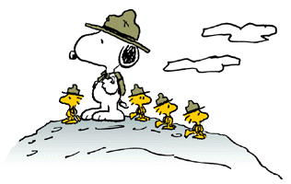

CAMP EMERSON
AT
BOSEKER SCOUT RESERVATION
WISHES TO ACKNOWLEDGE

SAM STARK

FOR MAKING USE
OF THE
KNOWLEDGE
LEARNED IN BOY SCOUTING

_____________________ _______________________ ______________________
CAMP DIRECTOR COMMISSIONER PROGRAM DIRECTOR

