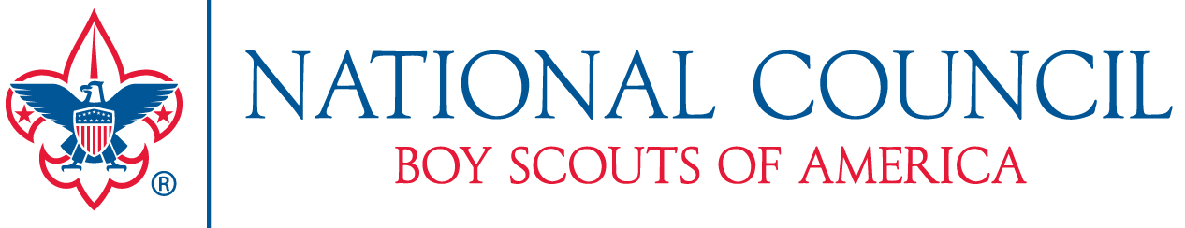

Media Contact:
David L. Harkins, Boy Scouts of America (800) 323-0732 x457
david.harkins@scouting.org

“Boy Scouts of America: Today” National Photo Contest
Coffee table book will be a visual representation of modern-day Scouting

IRVING, Texas (January 12) – As the Boy Scouts of America’s members, alumni, and admirers prepare to celebrate the organization’s 100th anniversary, they want to see what Scouting looks like in the communities across America. Anyone with a passion for photography is invited to submit photo entries for a new book, to be published in October 2010. Boy Scouts of America: Today will show Cub Scouts, Boy Scouts, and Venturers engaged in activities that represent the 12 points of the Scout Law.
Eligible participants may enter the contest by submitting photographs in any or all of the 12 categories to visually depict the 12 points of the Scout Law—trustworthy, loyal, helpful, friendly, courteous, kind, obedient, cheerful, thrifty, brave, clean, and reverent. Affiliation with the BSA or any of its programs is not necessary to submit a photo for consideration. Winning entries will printed in the book Boy Scouts of America: Today, and winners will receive a copy of the book and a $50 gift card for official Scouting merchandise purchased through Scoutstuff.org or at any participating Scout shop.
“The image should not just create a visual reaction, but must evoke a feeling about the point of the Scout Law for which it represents,” explains Roger Morgan, official BSA photographer. “We’re looking for photographs that create an emotional response.”
--more—

National Photo Contest
Page 2

The Boy Scouts of America: Today photo contest begins January 12, 2010, and entries must be received by March 31, 2010. Photos must be representative of Scouting activities but are not limited to any specific event. Photographs submitted for consideration must have been taken within one year of entry. Visit http://scoutstuff.upickem.net/engine/Welcome.aspx?contestid=12834 for more information including how to submit photos for consideration.

About the Boy Scouts of America
Serving nearly 2.8 million young people between 7 and 20 years of age at more than 290 councils throughout the United States and its territories, the Boy Scouts of America is the nation’s foremost youth program of character development and values-based leadership training. www.scouting.org

About DK Publishing
DK Publishing is the visionary book publisher renowned for pioneering a distinctive, highly visual style in its books for adults and children. Founded with the aim of developing innovative reference books, DK has since established a worldwide reputation for publishing high-quality nonfiction books in which words and pictures are closely integrated to present information with unrivalled clarity. Visit us on the web at www.dk.com. DK Publishing is part of the Penguin Group (USA), a division of Pearson plc.

###

